Problem 1
- (0 | 1)∗ (0 | 11 | 001) | ϵ | 1 | 01
- abba (a|b|c)∗ bac | abbac
- (0 | 1) (0 | 1) 0 (0 | 1)∗
- (1∗01∗01∗)∗ | 0∗10∗10∗
- (b∗ab∗ab∗ab∗)∗ b∗ab∗

Problem 2
- Strings over {0,1} that start with 01
- Strings over {0,1} that start with 0 or end with 1
- Strings over {0,1} that do not contain 00 as a substring
- Strings over {0,1} that have neither consecutive 0’s, nor consecutive 1’s
- Strings over {0,1} that may have consecutive 0’s, or consecutive 1’s, but not both

Problem 3

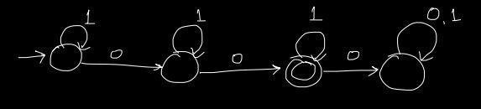



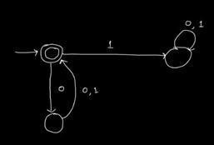

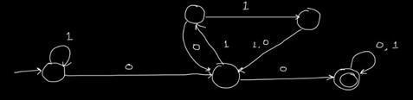

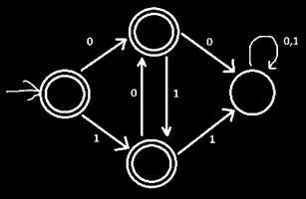

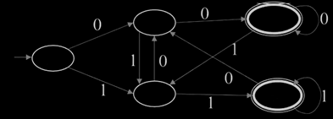

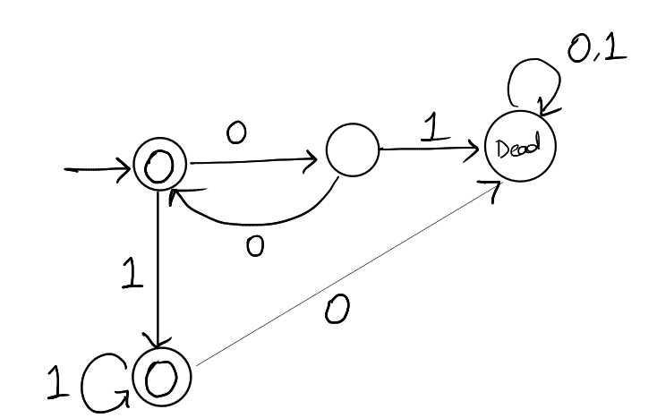

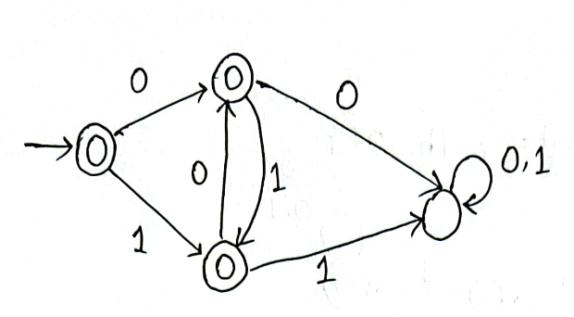 | 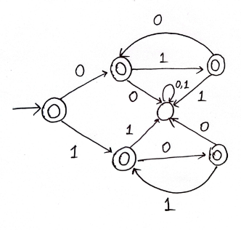

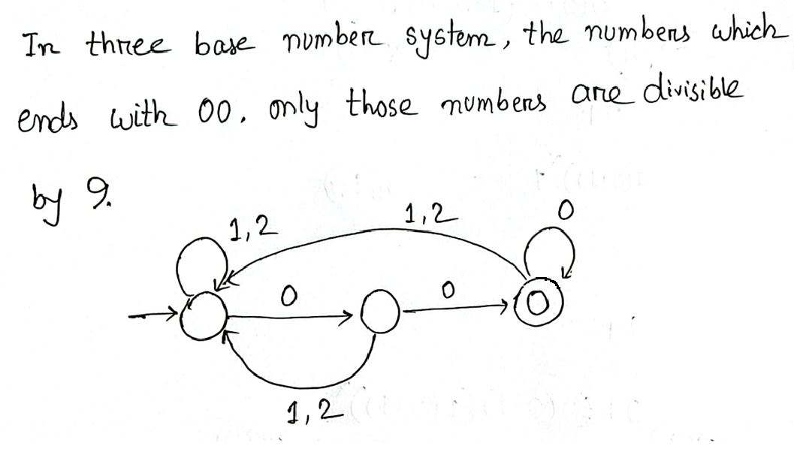
There is also a DFA with 9 states and 27 transitions - which is also correct.
The logic is - if there is a number x, in ternary representation, adding a 0 at the end will make the number 3x, adding 1 at the end will make it 3x+1 and for 2 it will become 3x+2.
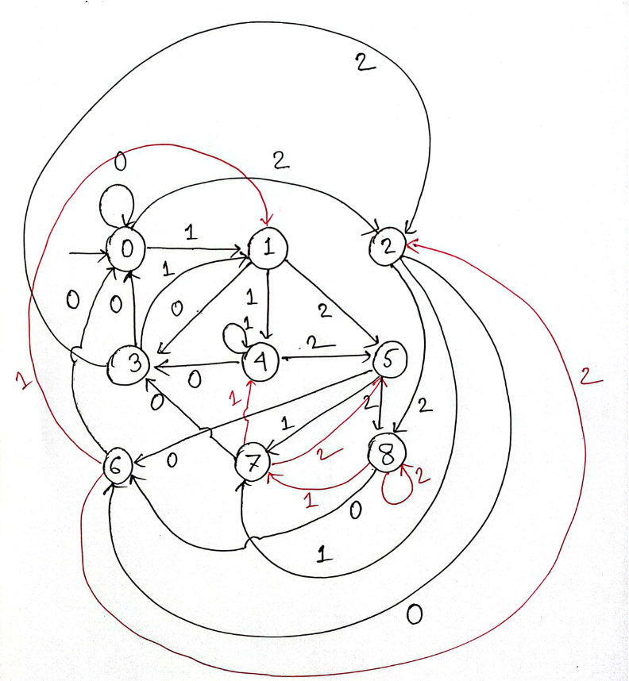

- 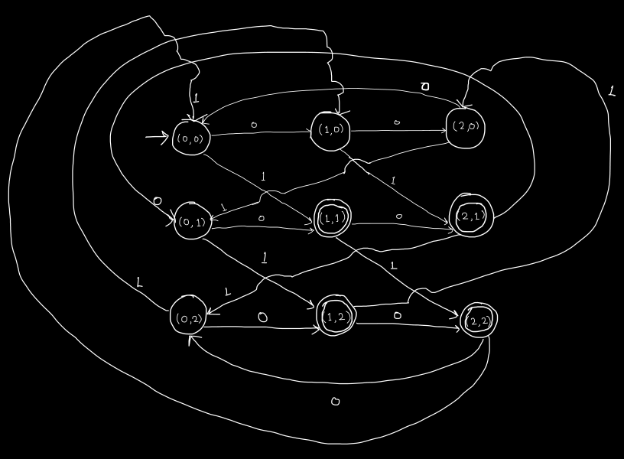

A correct solution is anything equivalent to the above. The DFA diagram is a bit clunky due to there being a lot of states and transitions. However, the idea is simple: the states are indexed by a pair (i, j) where 0 <= i, j <= 2, and i, j are the length and the number of 1s seen so far modulo 3. Upon seeing a new letter i goes up by 1, while j goes up by 1 only if the new letter is a 1.

The main observation is that i^2 + j^2 = 2 mod 3 iff i = 1, 2 and j = 1, 2 mod 3. This gives us four accepting states.

Any DFA for this language necessarily requires 9 states. So, any DFA with fewer states is wrong.

Problem 4
- Yes
- 1100
- 0100
- Yes
- No

